- Access Canon’s training site at: csa.canon.com/elearning
- Click on “Access and register to use eLearning”
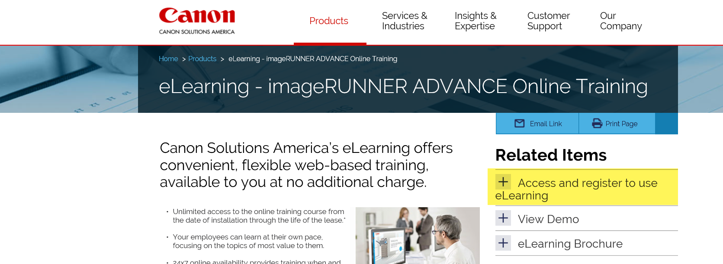
- Next, click on “Register”.
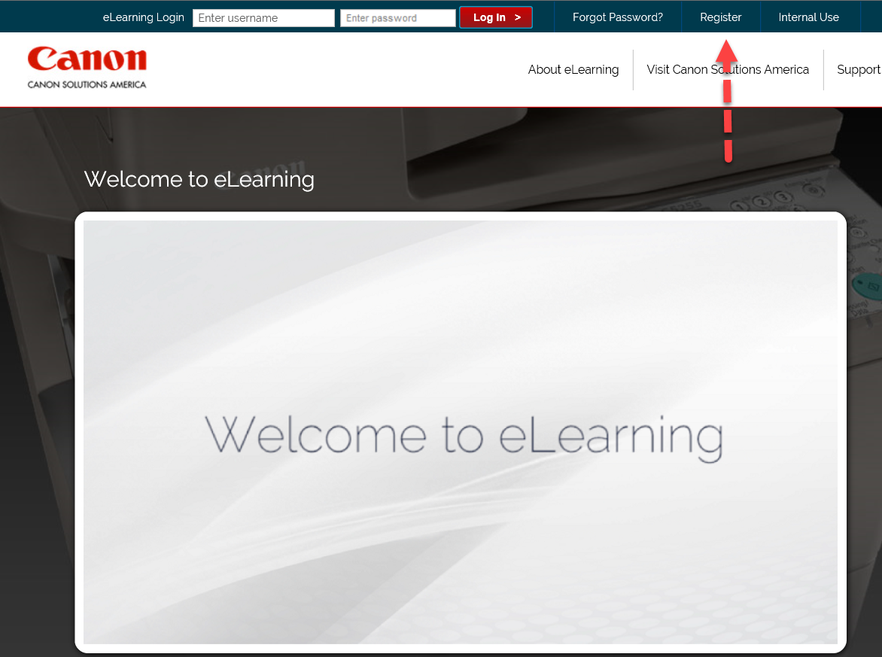

- Fill out the registration form completely then check off the terms and conditions agreement box. Finally, click on “Register” button.
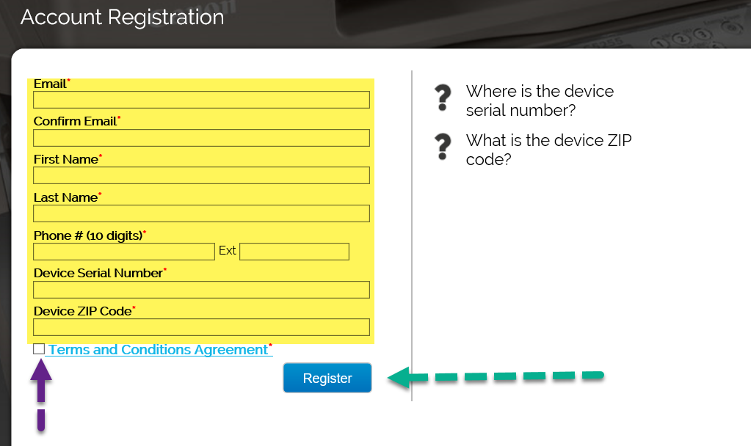
- If you have any questions regarding registration or training please contact Canon below.
