How to Caption Videos in Canvas Studio
Captioning your own videos in Canvas Studio is an easy process and a very important step in providing equal access for all students. Just make sure you keep in mind that these captions are machine generated. They're not perfect, and the system will obviously have more trouble with technical terms than everyday words, so you'll need to closely review and probably edit your captions. That said, it's still much easier to let the machine do most of the work and just do some cleanup of your captions than to transcribe all of your videos from scratch. Video captions must be at least 99% accurate to be considered compliant under accessibility laws.

Locate Media
In your Canvas Studio account, locate the media you want to view. You can view specific media in the My Uploads menu [1], or search for the media in the search field [2].

Open Media
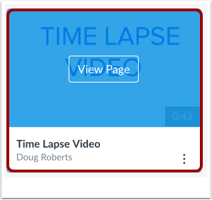
Hover over the media and click the Play image.

Add Captions
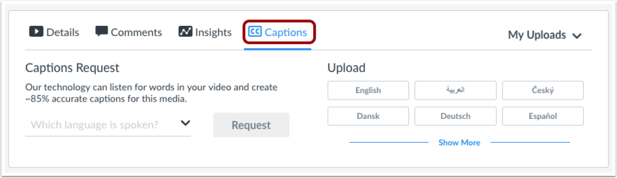
To generate or upload captions, click the Captions tab.

Generate Captions
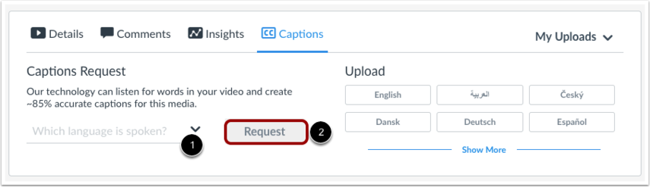
To automatically generate captions for your media, choose the spoken language [1] and click the Request button [2].

View Captions
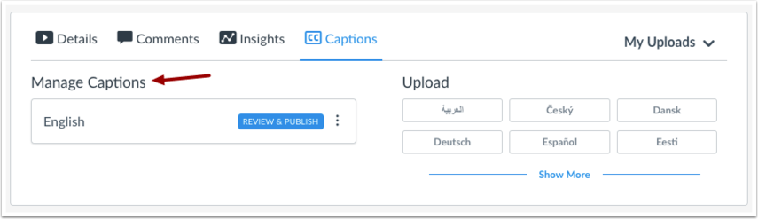
After your caption file has been queued and processed, your generated caption file will appear in the Manage Captions section.

View Caption Options
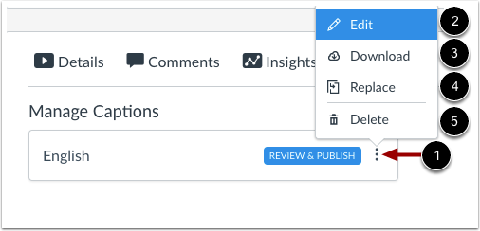
To view more options for the caption file, click the Options icon [1]. To review and publish the captions, click the Edit link [2]. When you are editing the auto-generated caption file, the media file will automatically pause until you click the next timestamp.
You can also download [3], replace [4], or delete [5] any caption file.

Review and Publish Captions
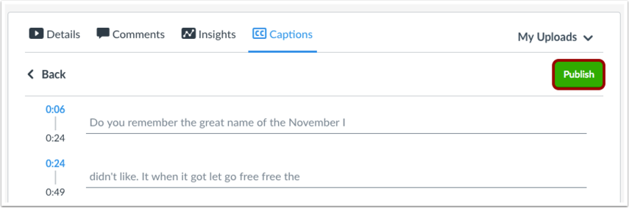
Review the generated caption file and click the Publish button. Any additional changes made to the caption file after it is published will be saved automatically.

