To Start a Conference in Canvas
- Select Conference from your Canvas Course menu
- Select (+) Conference to create a conference room. A pop up will appear to allow you to customize the room settings.
- 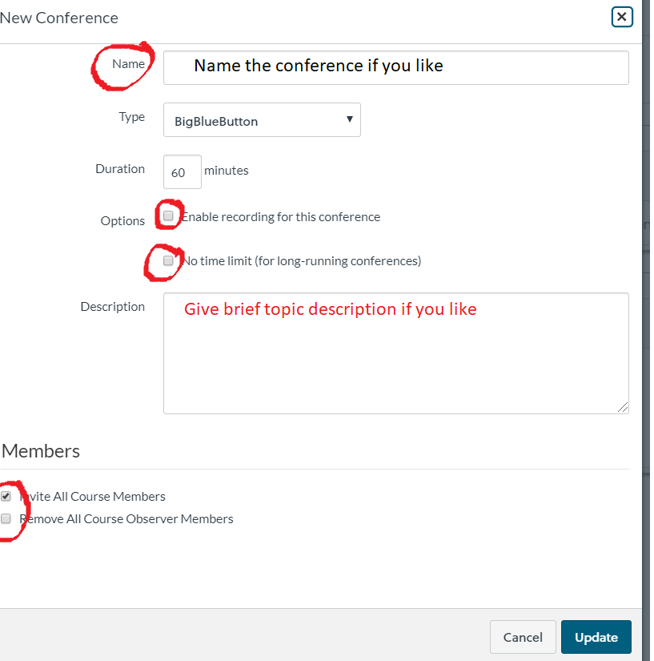
  - Name the Conference
  - Enable Recording. You must choose this at this point.
    - You can always choose not to start the recording , but you can’t change your mind TO record later.
    - You must start recording in the next screen
  - Choose the length. I select no time limit, for flexibility
  - Click on the UPDATE button.
  - If you want an email sent to everyone in the course with a link, then invite them all. Otherwise, de-select this. You can send selected people the link. Anyone with the link can attend.
  - Once the Conference room is defined, you can join it. If you invited all students, this active link will appear for all to join.
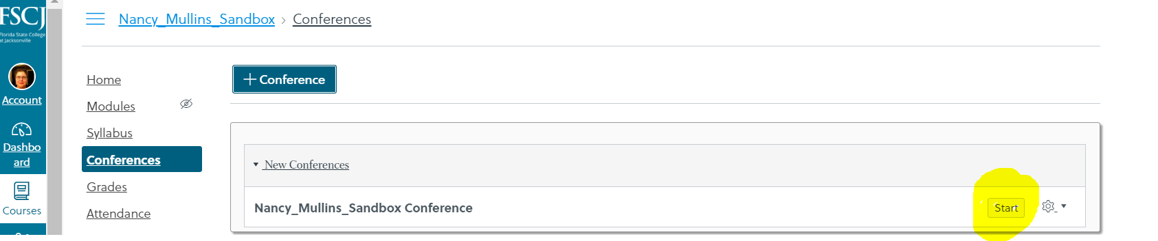

Connecting to the Conference Room
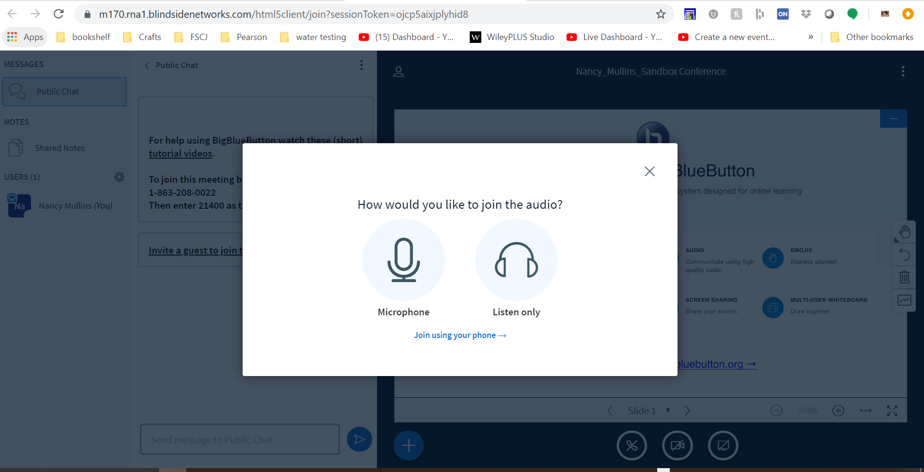
Choose the microphone if you want to be able to add audio using your headset, camera mic, etc. You can choose your input later. If you select listen only, you can only add audio via phone call in later.

**Pro Tip: If you are an attendee, choose the microphone, then mute yourself until you need to speak. This makes it much easier to hear and understand the conference audio. The following will pop up. Allow it. Again, you can always mute your mic, but can’t add it in later.
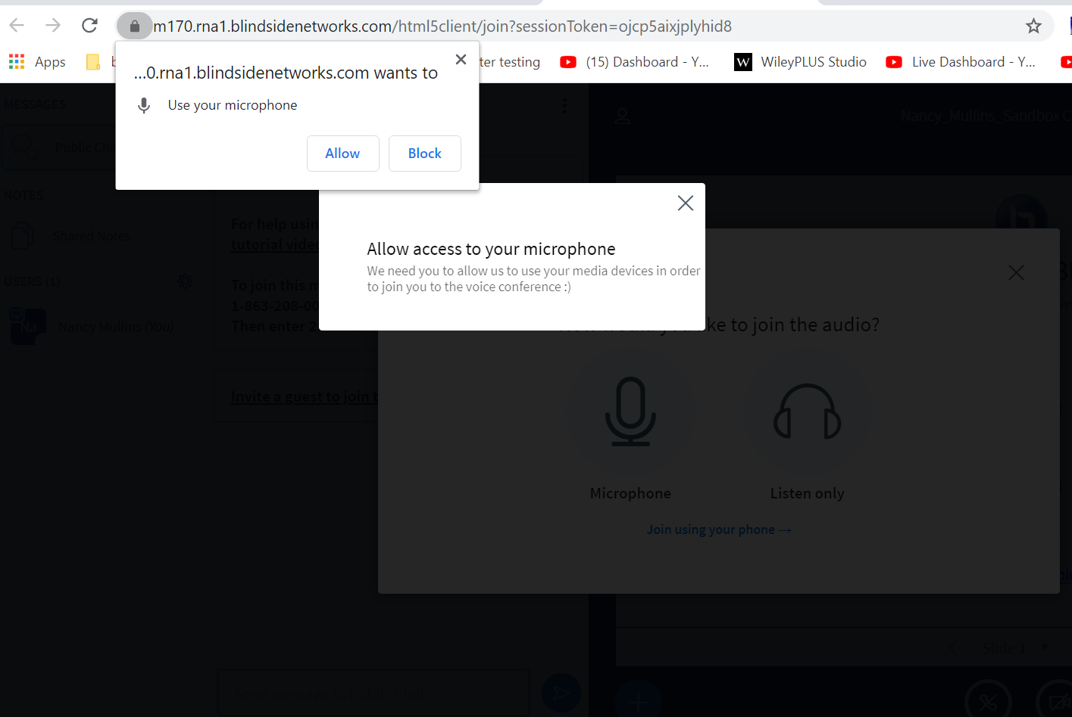

The Conference Window will not appear.
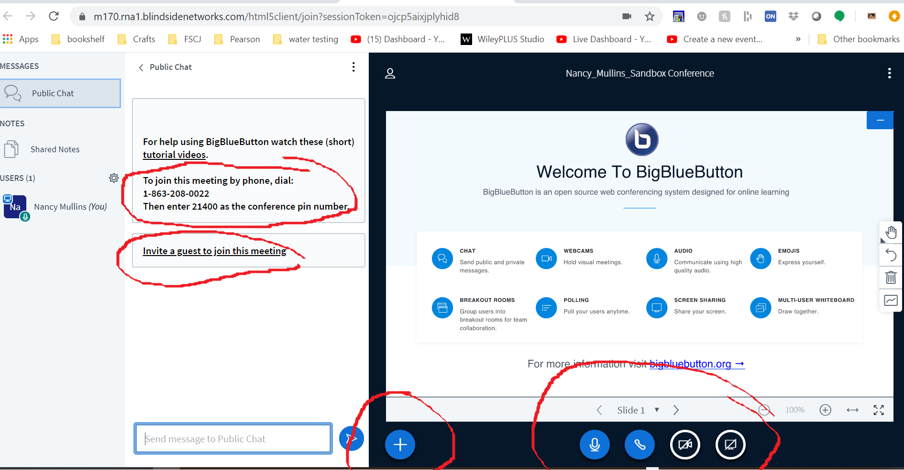
Each conference gives you a dial in number that is unique, and a conference pin number. This is how you can dial in to connect your phone as audio input. You will still be able to mute your phone as an attendee or host.

Note the Invite a guest Link. Clicking this link will generate a conference specific URL. You can email this link to anyone that you like: In or out of the college. Anyone with the link can join the conference.
***Pro Tip: If you want to use your cellphone camera as audio AND camera, email yourself the link and join the conference this way!

Note the option to mute is the microphone in this screen

To disconnect audio, click the phone handset

As host you can share either your computer’s camera or desktop.
***Pro Tip: If you are using your cell phone as a camera input instead of you’re a connected computer camera, join the conference as an attendee with your phone. Then share your camera. If you keep your phone plugged in, you will have longer life!
Only the host can share their desktop!

When you share your desktop, you must choose desktop/specific application/browser tab. Most of the time, entire desktop is easier if you move between applications during your conference.
***Pro Tip: You must select the correct tab, and ALSO click on the image of the desktop or application, etc. Then click SHARE
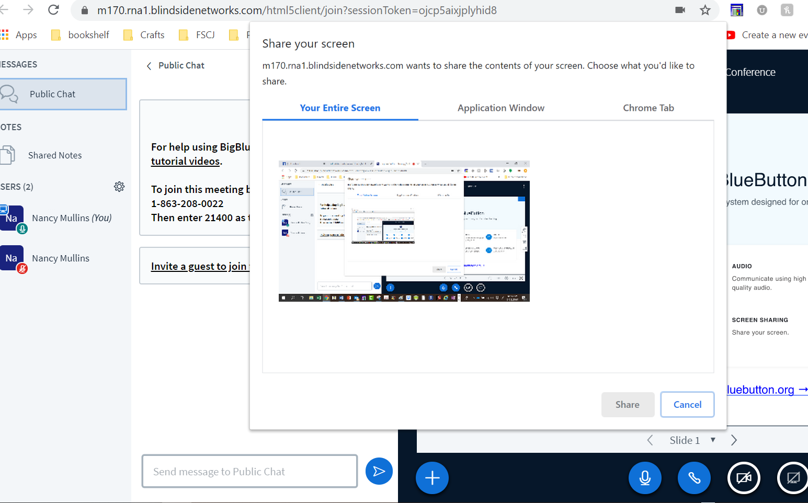
Don’t fear the tunnel!!! As long as you keep this tab open, you are still in the conference. Feel free to click to whatever apps you want to demonstrate. Come back to the tab to change inputs, check for questions/poll the group, etc…

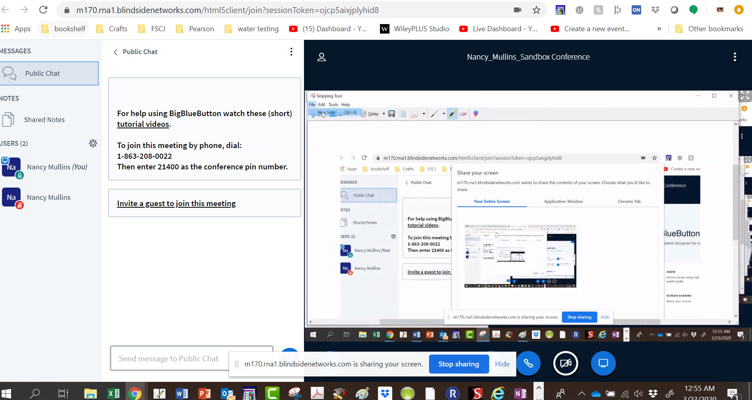

You can hide the screen sharing icon if it annoys you. You can always stop sharing later

ACTION (+) button for Host:
Allows you to poll
Upload a ppt or document
Share a video

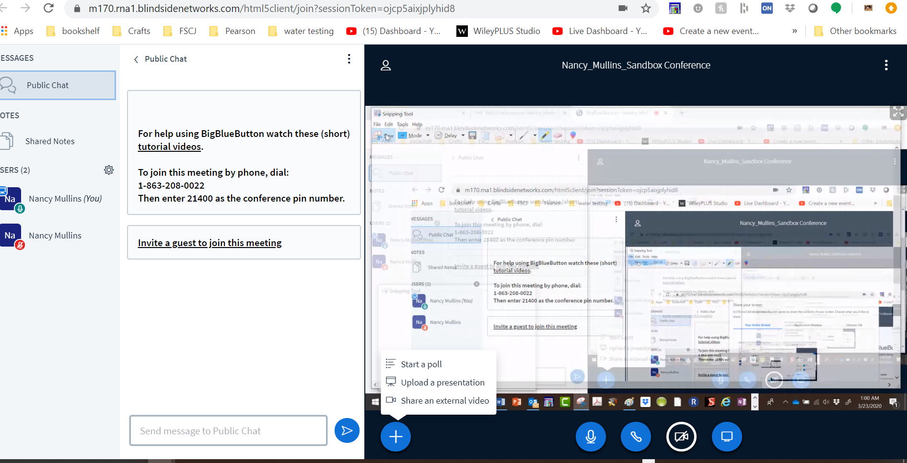

If you are an attendee, your action button will allow you to take presenter mouse ability to point our things on the host’s screen if they allow it. Note that you can choose which camera input you would like to see/maximize.

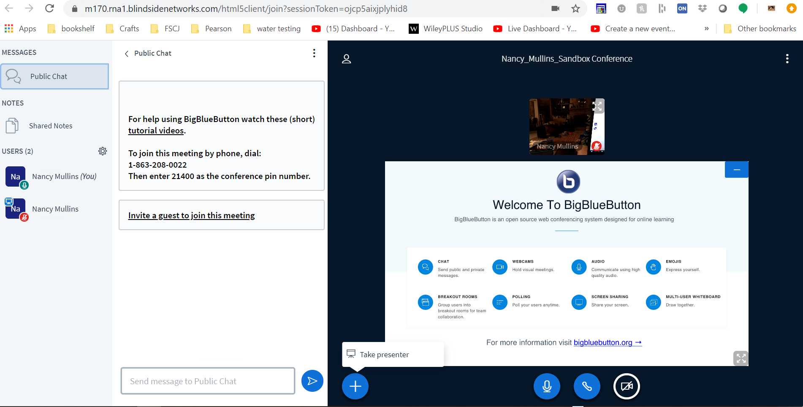

Hosts can eject attendees, remove audio rights, or start a private chat.
***Pro Tip: Turn Off screen sharing before you attempt a private chat!

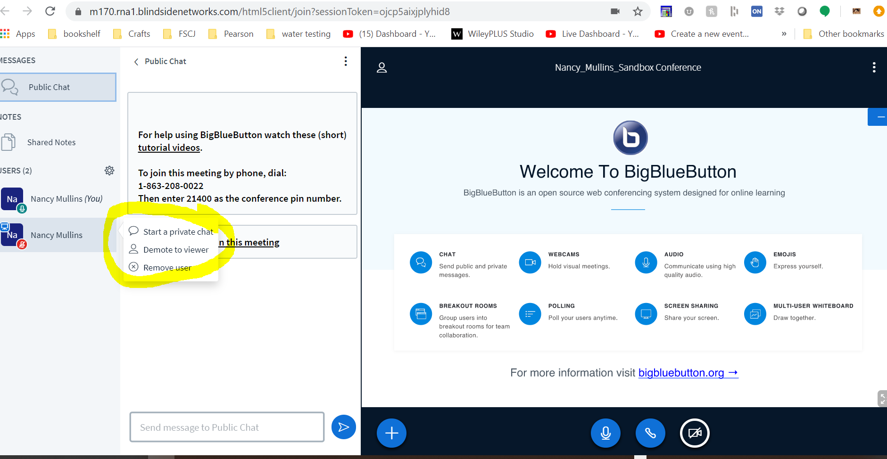

When you are Done with the Conference, End the meeting window
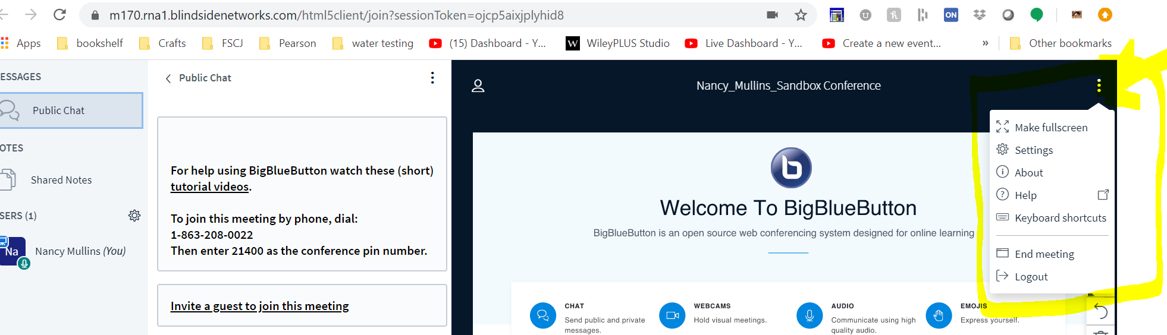
And then go to conferences to close the room
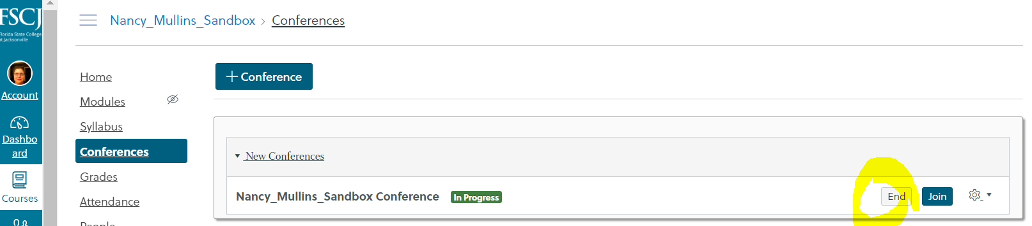

 | Host | Guest | Guest Presenter
Can share camera and connect to audio using computer or phone | Y | Y | Y
Can share Desktop | Y
Can record | Y
Can choose window to observe | Y | Y | Y
Can dial in for audio and camera connectivity | Y | Y | Y
Can use email link to connect to conference as an attendee | Y | Y | Y
Action Button Allows you to create poll | Y |  | Y
Action Button Allows you to share Presentation | Y | Y | Y
Can Eject, retake presenter or remove audio rights | Y

*****Pro Tip: For Polling, you will likely want to prepare your questions ahead of time, then share the application on which the question appears

